- Enable CloudTrail monitoring and store the events in S3 and CloudWatch log events.
Created a new bucket and cloudtrail and cloudwatch as well.
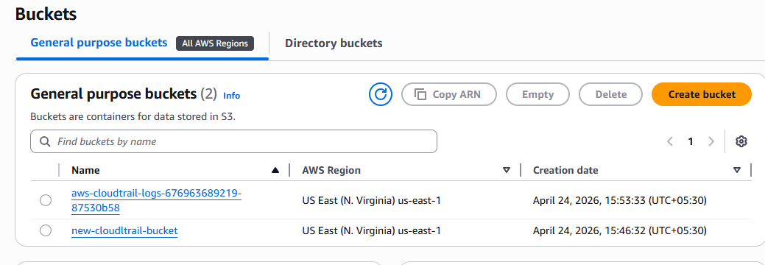
Cloud trail new created. 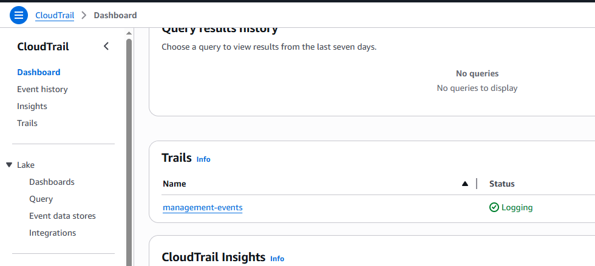

Cloud watch new created with log information: 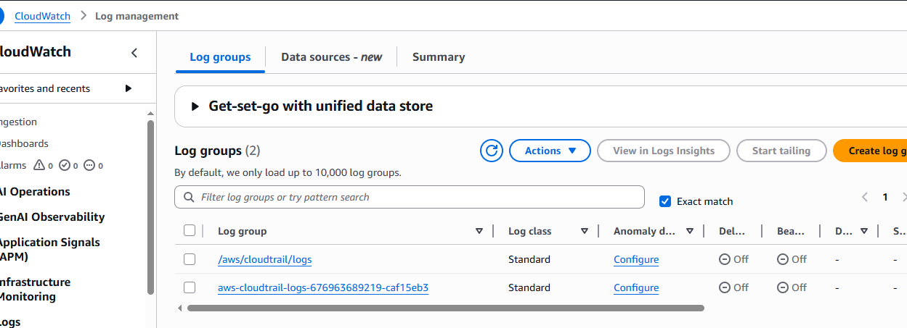
Logs shown in the below image for s3: 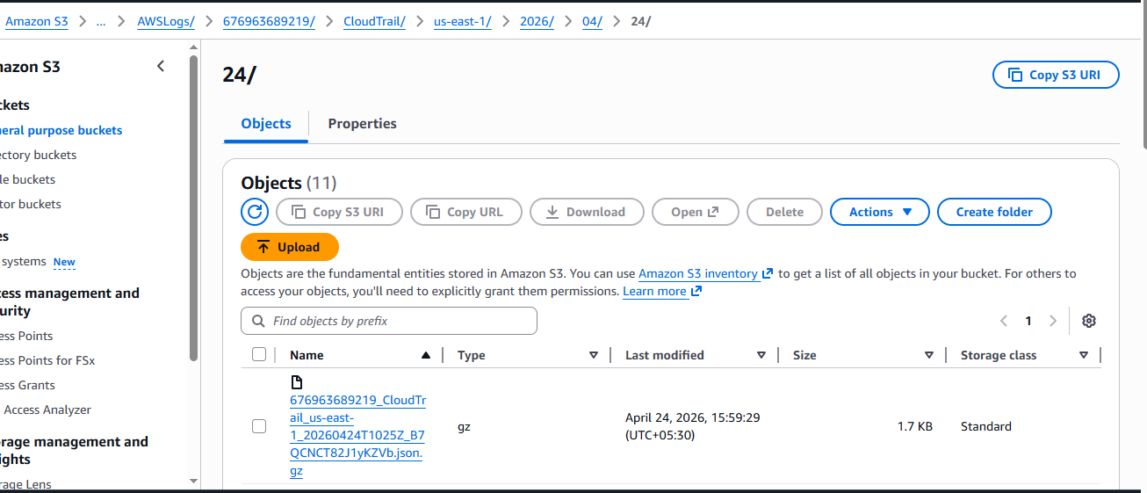
Cloud watch with log details shown in below image: 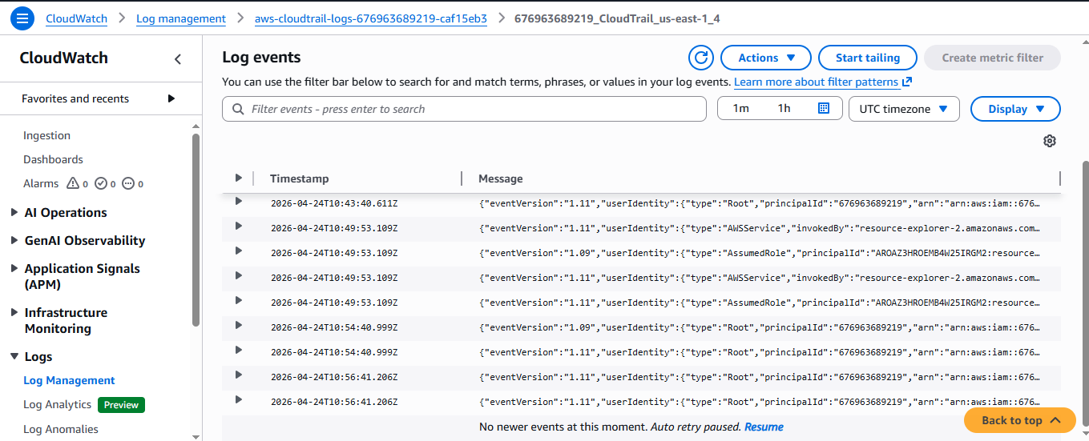

- Enable SNS for CloudTrail to send alerts via email.
Created a new topic for SNS and then created a new subscription as well.
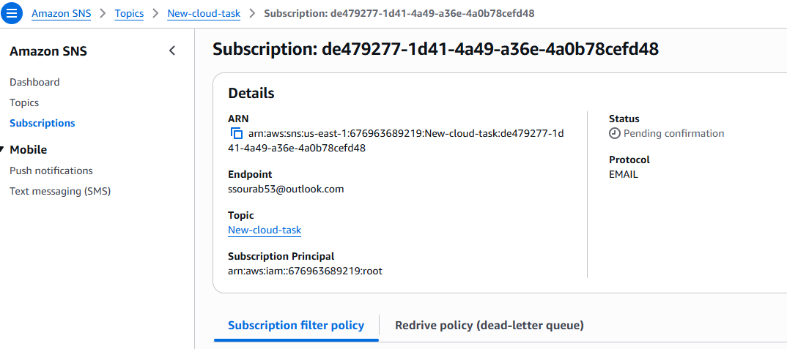
Updated and confirmed the registered email with validation:
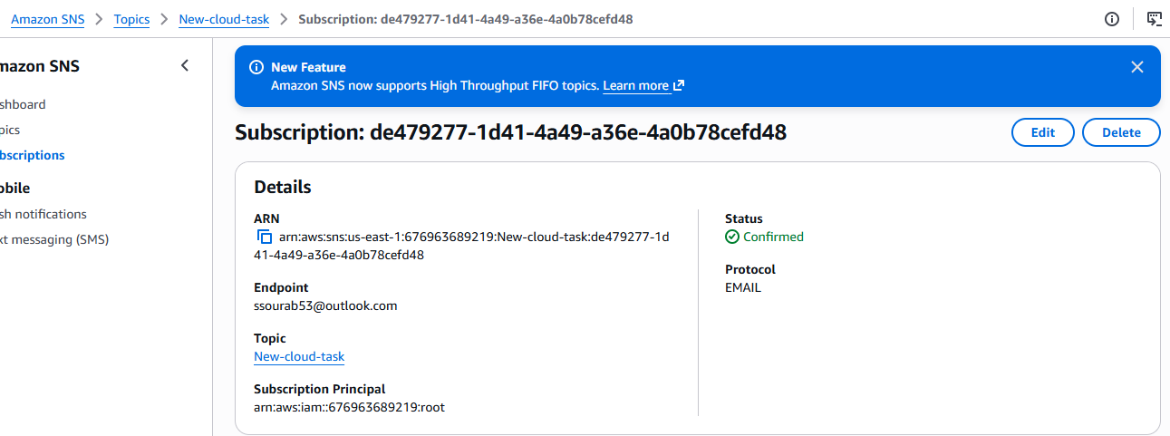
created an alarm with a new metric then got an email for the value >1.
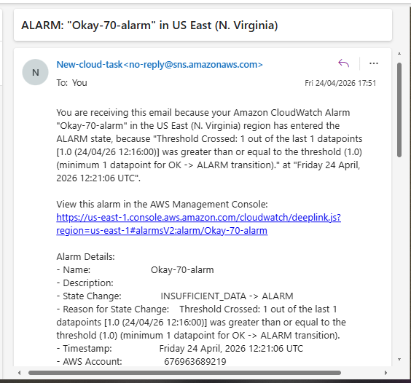
- Configure CloudWatch monitoring and record the CPU utilization and other metrics of EC2.
Enabled the detailed monitoring option from the actions dropdown on the right hand side. 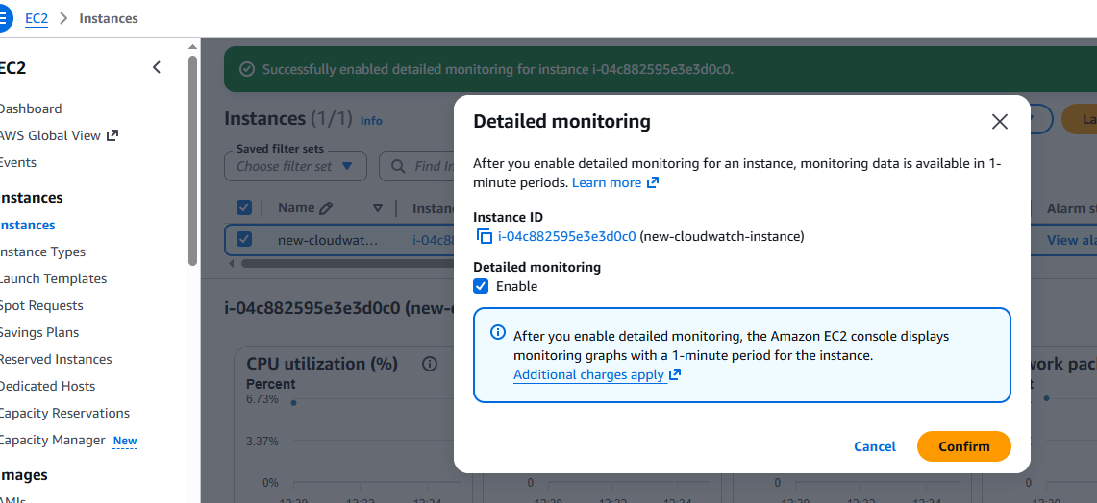
created a new metric for the CPU utilisation to monitor new ec2 instance for everyone minute.
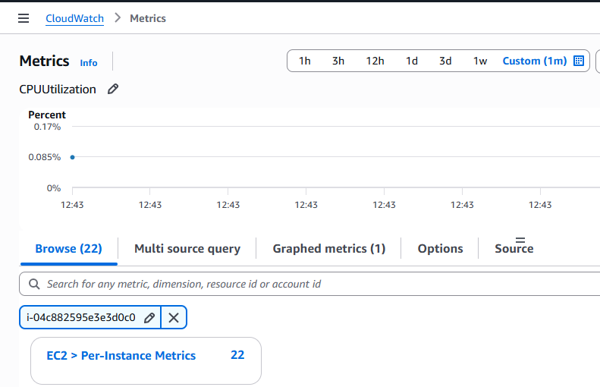
- Create one alarm to send an alert to email if the CPU utilization is more than 70 percent.
created a new alarm for cpu utilisation for >70%.
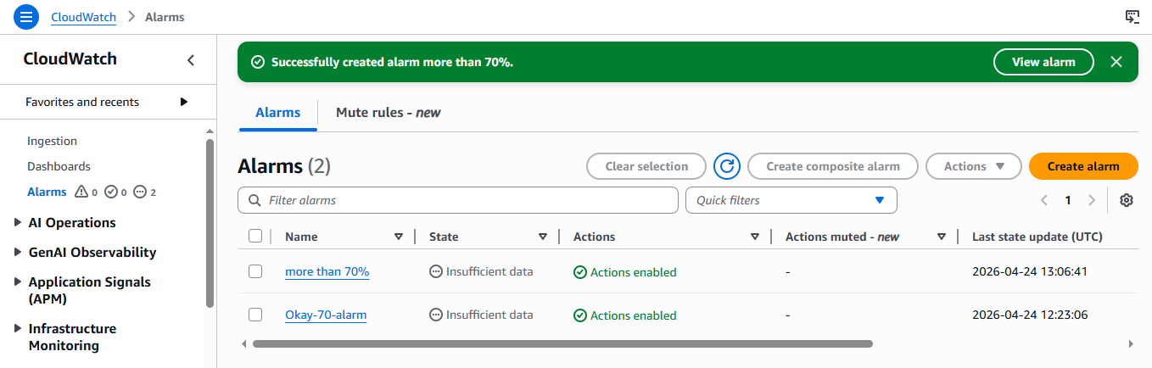
Wantedly created a load on cpu and checked with the cli command to get the email as shown in the below image.
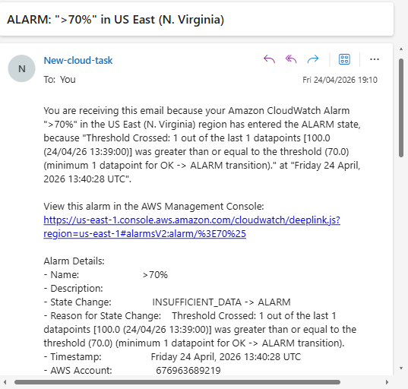

- Create a Dashboard and monitor the Tomcat service whether it is running or not and send the alert.
installed crontab:
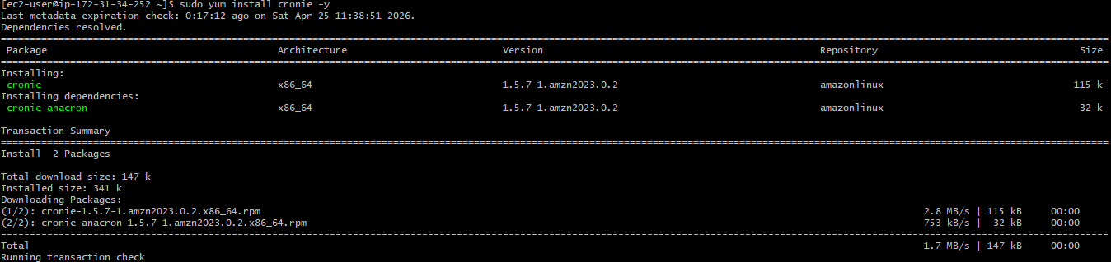
Installed java 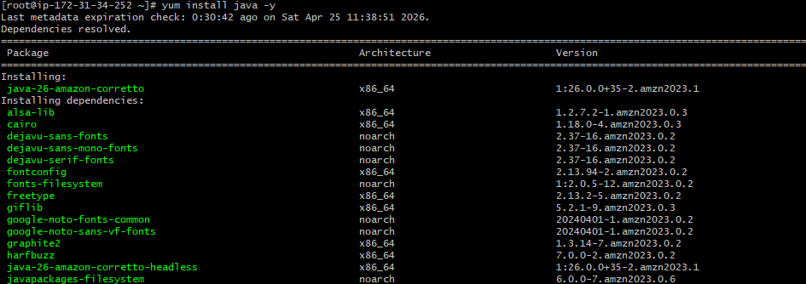
Installed Apache tomcat 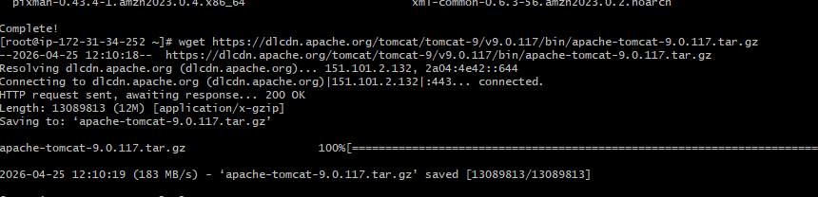 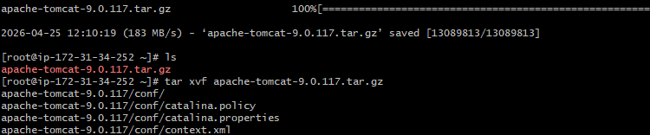

started tomcat: 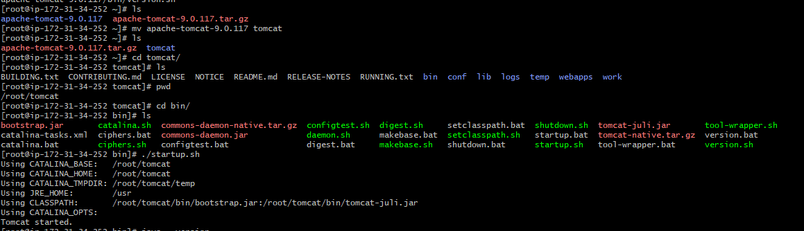 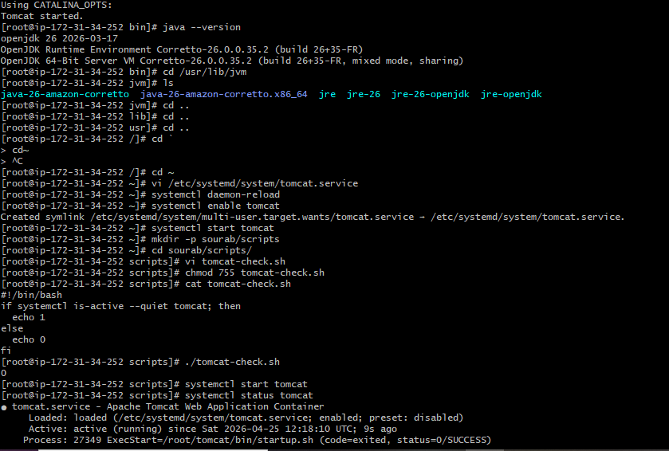 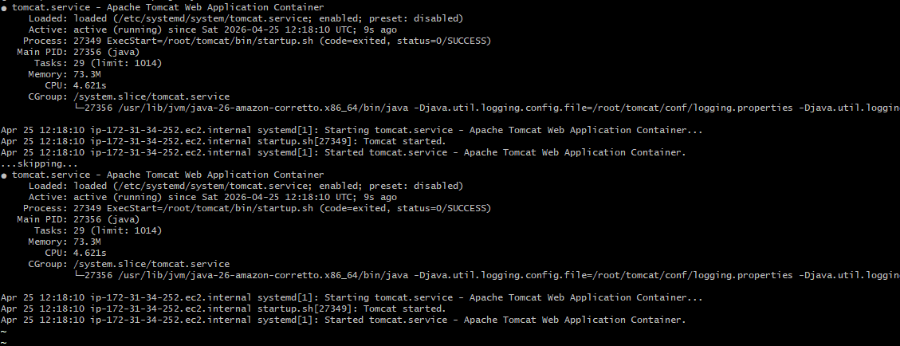 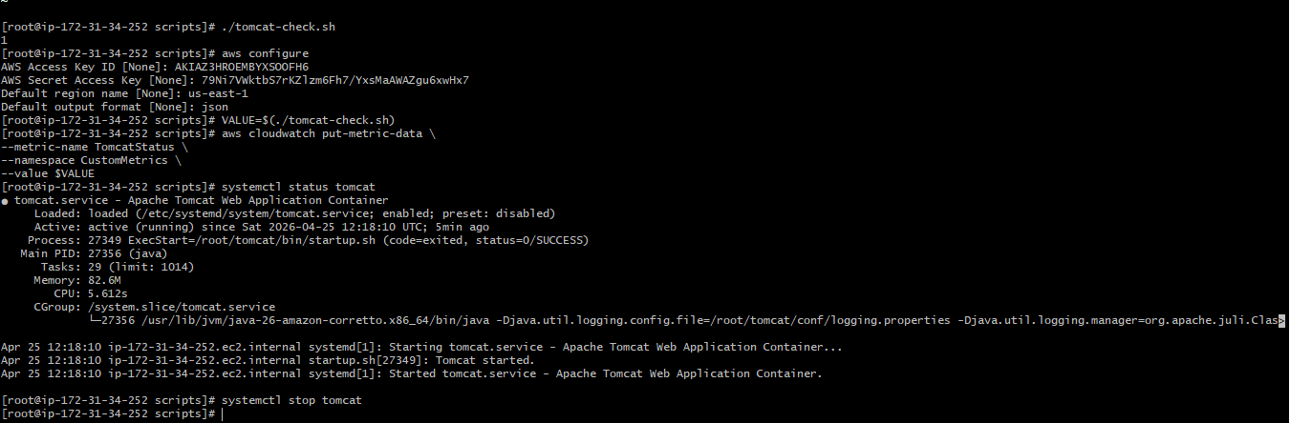
- Create a Dashboard and monitor the Nginx service to send the alert if Nginx is not running.
Installed nginx on the new instance 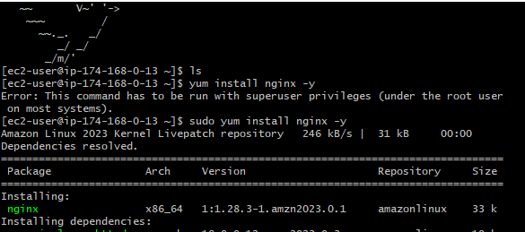 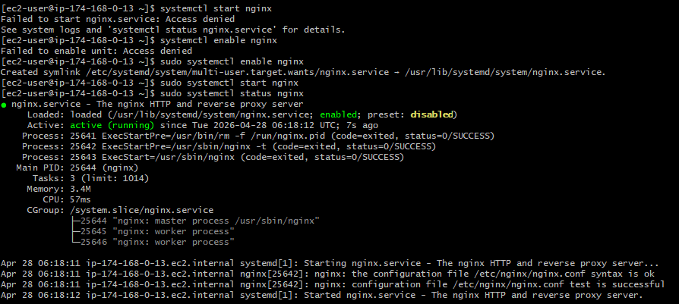
installed cronie (crontab) then created a new file with the scripts in it and then run the command:
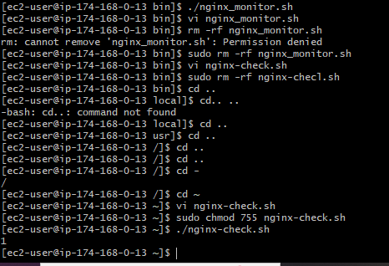
Stopped the nginx and then checked with the same file:
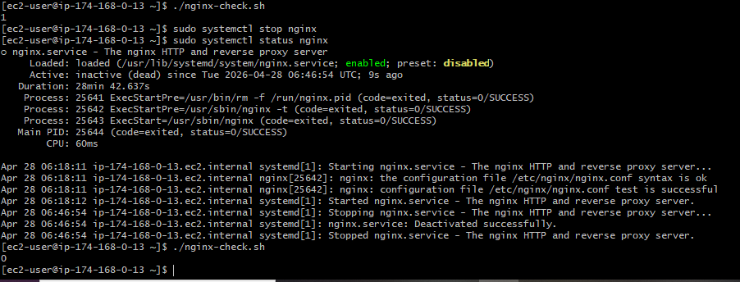
After this need to do aws configure and then follow below steps:
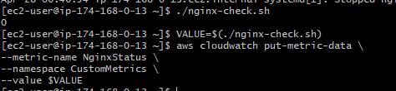

Then created a new alarm in the cloudwatch and then checked with the email to get email alert:
